
ScreenPro™ Quick Start Guide

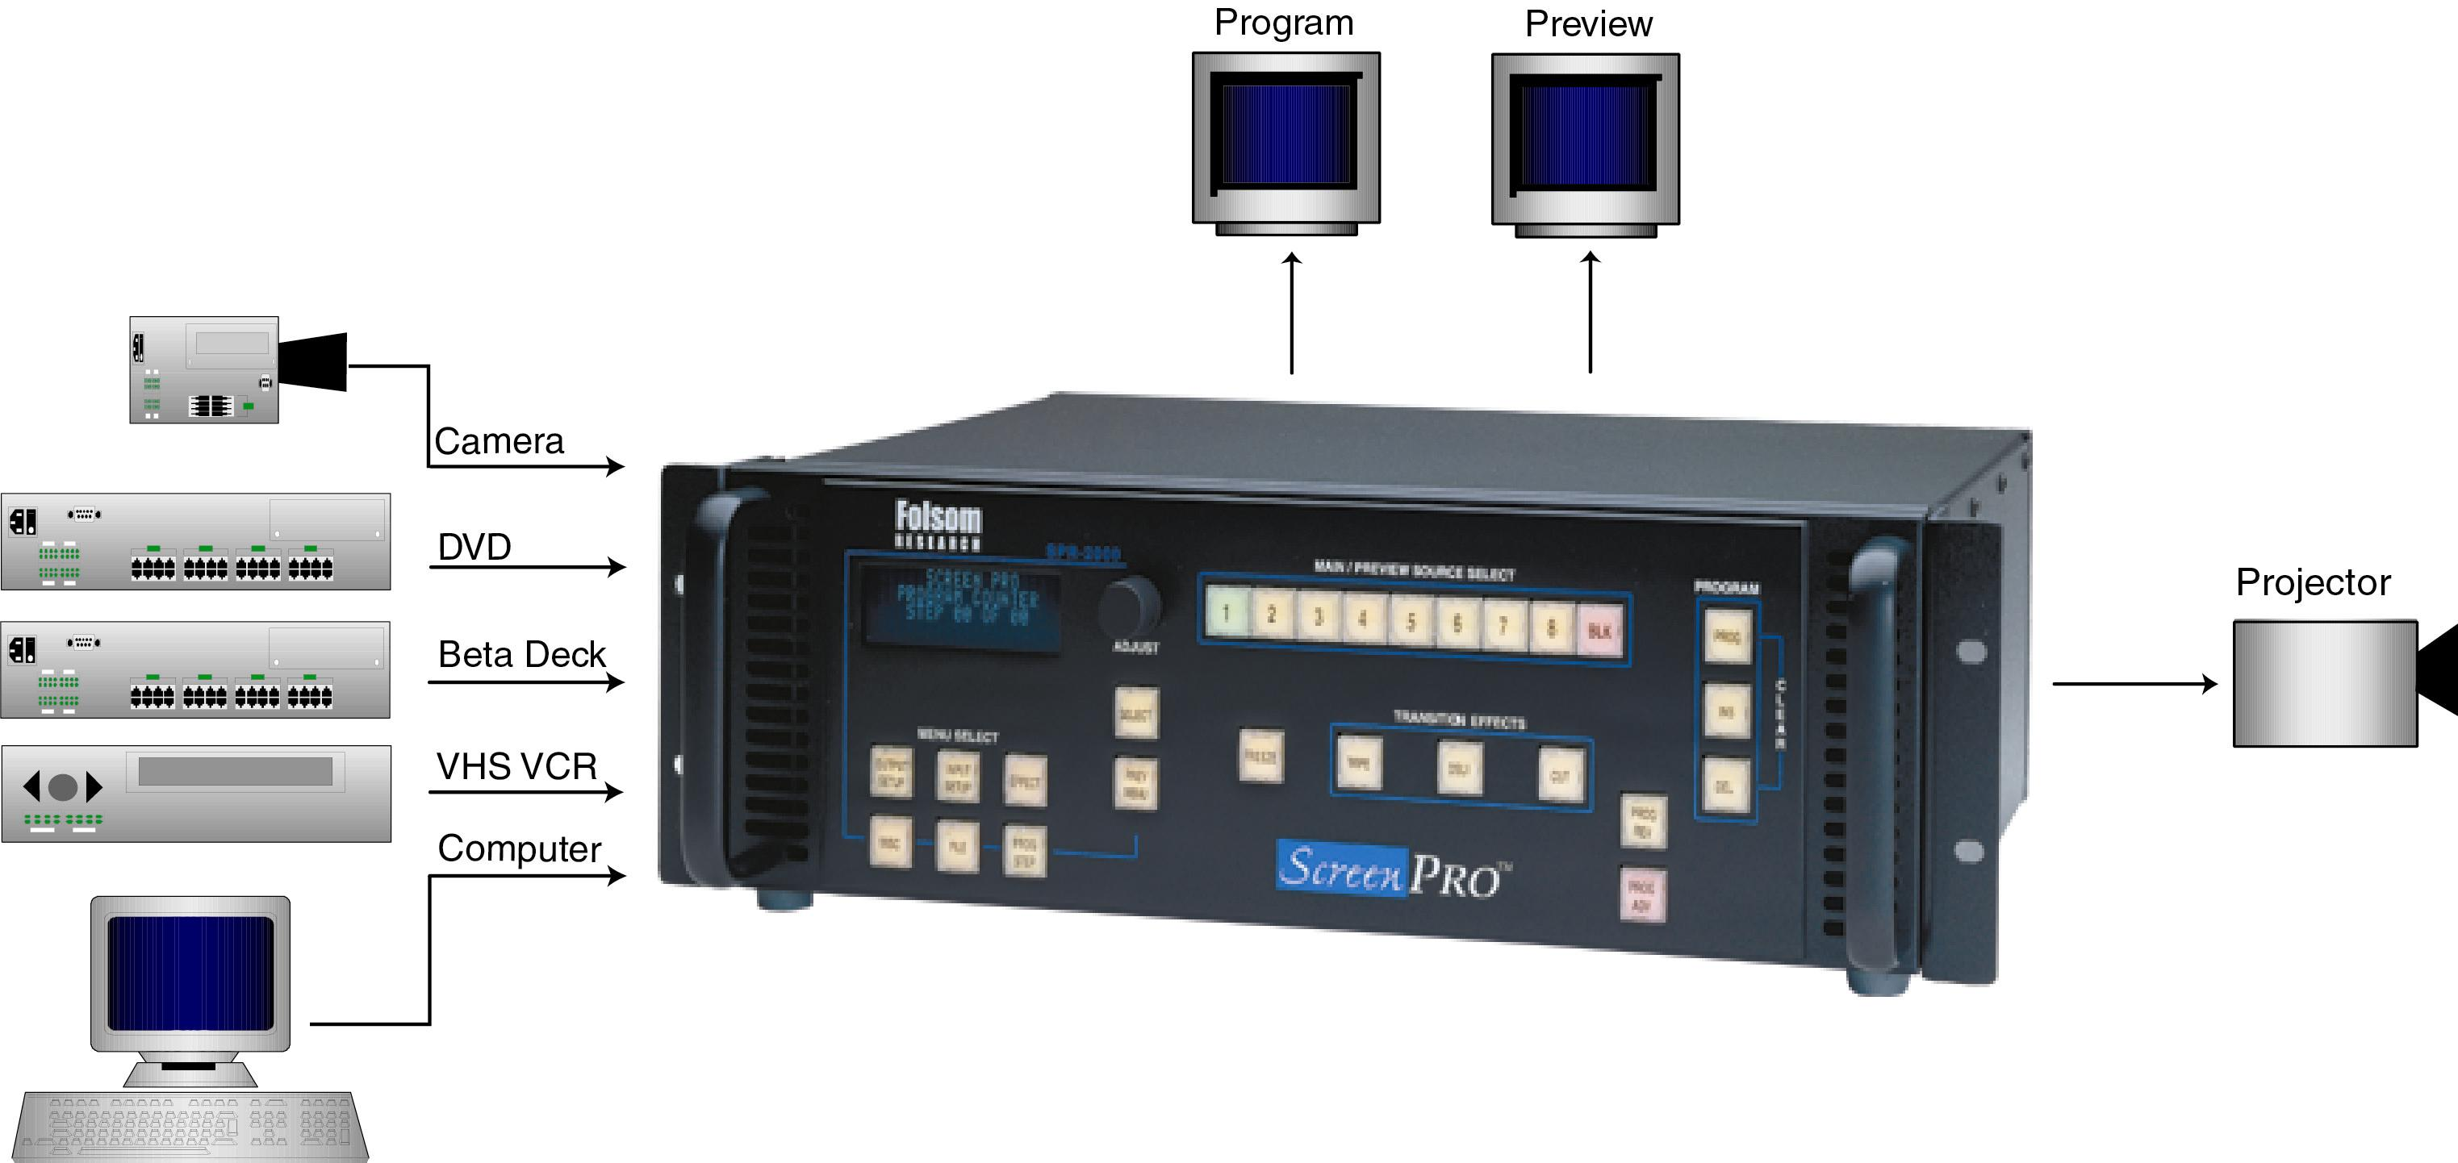

Illustration of Typical ScreenPro™ Setup

Step 1: Connect ScreenPro™ to Output Devices
Connect one of the two available “Main” outputs to your projector. Note that the second main output may be connected to a local display monitor if the projection screen is not easily viewed by the operator.

Connect the “Preview” output to a computer monitor. (Note: The preview output timing is identical to the main output. If the main output is set to 1280 x 1024, the preview monitor must be capable of that resolution.)

Step 2: Connect Input Sources to ScreenPro™
ScreenPro™ has eight universal inputs that accept composite (NTSC & PAL), S-video, component, and computer video sources. Connect each type of input source to ScreenPro™ as indicated in the following table.

Input Connections

Format – RGB  (Typical Devices: Computers) |  |  | Format – YUV or Y Pr Pb (Betacam)  (Typical Devices: DVD Player or Betacam Deck)
Source to ScreenPro™ |  |  | Source to ScreenPro™
R | R/CR |  | Y | G/Y
G | G/Y |  | Pr | R/CR
B | B/CB |  | Pb | B/CB
H | H/C |  | or
V | V |  | Y | G/Y
Format – S-Video (Y/C)  (Typical Devices: S-Video VCR) |  |  | U | R/CR
 |  |  | V | B/CB
Source to ScreenPro™ |  |  | Format – NTSC/PAL (Typical Devices: NTSC/PAL VCR)
Y |  | G/Y | Source to ScreenPro™
C |  | B/CB | NTSC/PAL | G/Y

Step 3: Power Up
Connect ScreenPro™ to 115 VAC power using the power cord supplied with the unit. Locate the power switch on the power entry module at the rear of the unit and turn the power on. The unit will flash all of the front panel illuminated keys in unison, first with red, then green, and then white. While the main board is initializing, “please wait” will be displayed. The front panel display will show the main menu and this indicates the unit has powered up successfully.

Step 4: Power Up Display
The default power-up condition is to set BLK (black screen input) as the “Main” source and Source 1 as the “Preview” source.
The key for the source currently selected for the main output will be red. The key for the source currently selected for the preview output will be green. The remaining source selection keys will be white.

Step 5: Key Selection and Transition
The user can easily select any of the input sources as the current preview source simply by pushing the corresponding source select key. Each time a new preview source is selected, the key for the selected source will turn green and the video on the preview monitor will display output video derived from the newly selected preview source. The currently selected preview source can be transitioned seamlessly to the main output using the Transition Effects keys. After selecting a preview source, simply press one of the three transition effect buttons. The preview source automatically and seamlessly switches to the main output and the input source previously designated for the main output and will then become the new preview source.

Step 6: Select Desired Output Format
Set the video output from ScreenProTM to match the projector or other display device. Enter the Output Setup menu by depressing the OUTPUT SETUP key. The OUTPUT SETUP key will turn from white to red.
An arrow “>” will be displayed next to “FORMAT.” Press the “Select” key. A solid block will start to flash in the arrow location. Rotating the encoder dial will scroll through the available output resolutions. Stop on the desired output resolution and press “Select.” The output is now set to the desired output format. When finished, press the OUTPUT SETUP key and the display will prompt the user to save the output settings. Pressing Select (SEL) will save the output parameters to Flash memory and pressing PREV MENU will exit the output setup menu.

Step 7: Projector Adjustments
Proper projector setup is critical to optimize the quality of the output image. Once ScreenPro’s output is set to match the native resolution of the projector, the scaling engine in the projector should be disabled. The methods used to disable the internal scaler within the projector vary from manufacturer to manufacturer. ScreenPro’s Output Setup menu allows the user to select test patterns that are used during projector adjustment. Please consult the operator’s manual for your equipment.

Step 8: Configure Input Sources
ScreenPro™ will automatically lock to video applied to the eight universal inputs and will make a “best guess” at the video format (RGB, YUV, S-Video, NTSC/PAL) and all associated video parameters. While the “best guess” approach generally leads to an acceptable output image, it is strongly recommended that the user set up a configuration file to precisely define the video parameters associated with each input before running a show. The use of configuration files provides consistent, repeatable operation and allows the user to adjust video parameters for each source to optimize image quality. Up to 64 configuration files can be stored for use. Each time a source is selected with the Source Selection keys, the configuration file associated with that source is automatically reloaded.

Setting up input configuration files is simple. Proceed as follows for each input.
- Select the source you wish to work with as the Preview source.

- Press the INPUT SETUP menu key. Examine the image on the Preview monitor and adjust the input parameters as desired. The Input Setup menu is described in detail in Section 6.5 of the Installation and Operating Manual. Many of the parameters may require no adjustment, however, be sure that the INPUT TYPE menu item is selected to match the incoming source. Also verify that the type of sync indicated in the PROCESSING submenu matches the incoming source.

- When the input setup parameters have been set as desired, enter the SAVE submenu to save the setup parameters as a file. The next available file number is automatically shown on the first line of the SAVE INPUT FILE menu. You can use this file number to create a new file or assign another number. The third line in the menu allows you to assign an eight-character file name to the file. Entry of a file name is optional. When the file number and name have been entered, select SAVE to save the configuration. The file is saved and automatically assigned to the source used for the input setup process. The input configuration file will automatically be recalled for use each time the source is selected.
This is a quick reference guide. For detailed information on the ScreenPro™, please refer to the
Installation and Operating Manual supplied with your unit.

Folsom Research, Inc. • 11101-A Trade Center Drive, Rancho Cordova CA 95670 • (916) 859-2500 • www.folsom.com

Part # 26-0002902-00 Rev. B

