Compass S2 Helm Loader Operation

Needed items:

Latest S2 HELM firmware upgrade CD or email from FSR Tech support
DB9 Male to DB9 Female straight through serial cable NOT a null cable.
Computer with a COM Port operating with Windows 95 or higher.

- Introduction

The S2 HELM Loader is designed to work with newer Helms, which have VFD displays. It will not work with the older 7 segment displays. Contact FSR for factory upgrade options on the older style S2 Helms. They can be converted to the newer VFD display type for a charge.

When the S2 HELM is powered, press the blank button to the right of the PIP button on the S2 Helm console to determine the firmware versions currently running of the S2 HELM RACK and S2 HELM CONSOLE to verify that an upgrade is necessary. Lower numbers indicate earlier versions.

The versions listed below are the most recently released versions.

S-2 Application 8.01for the S-2 Helm RACK unit
S-2 Application 7.06 for the S-2 CONSOLE unit

“Unpacking” the software:

If you received an email or CD from FSR with the upgrade attached in the form of a “zip” file you should first create a folder to unzip the files to. You can name it whatever you like (Usually “S2 HELM LOADER”.)

Using your zip utility, extract the files to this folder

Locate and open this newly created folder and find the file named SETUP.EXE Double click on this file to load the program onto your computer. This will start the install wizard and allow you to step through the windows shown below.

Simply follow the prompts to install the program. The last window will complete the installation and give you the option of launching the loader program by checking the box. The wizard will also install an icon on your desktop to start the loader process.

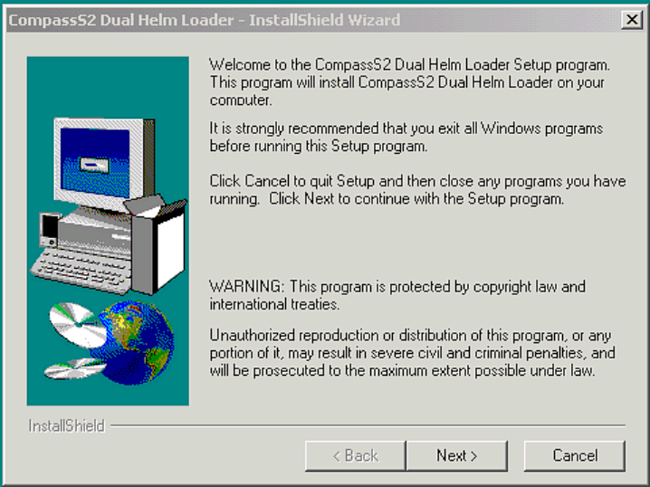

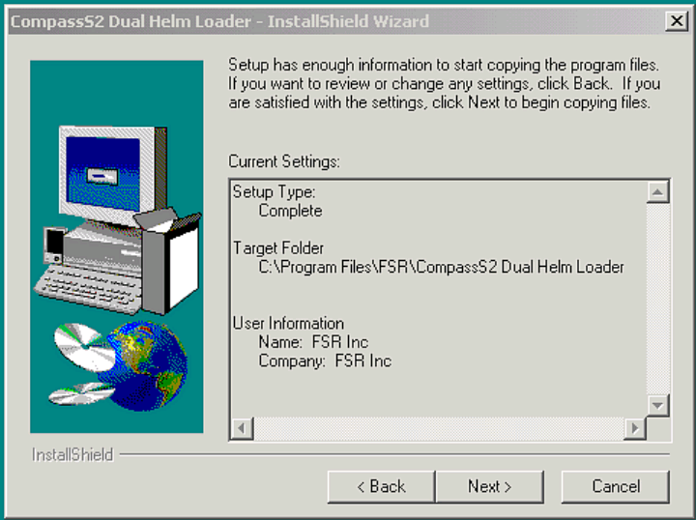

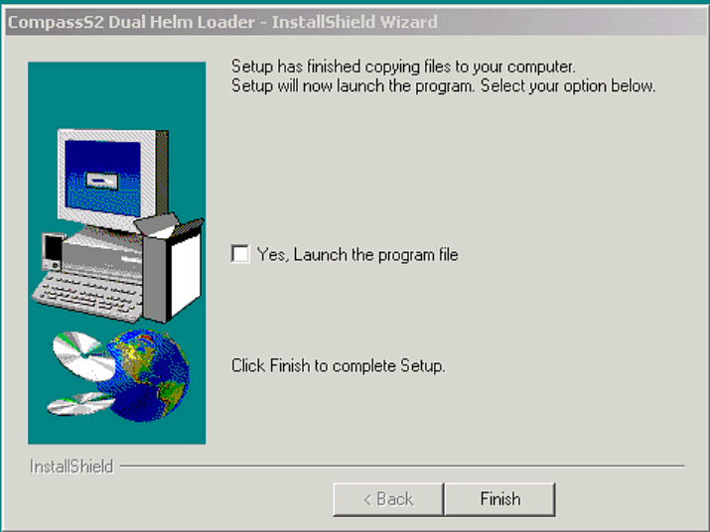

Either checking the “Yes” box above or double clicking on the newly created icon will start the loader program

Loader icon as it appears on desktop

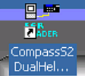

S2 HELM Loader window 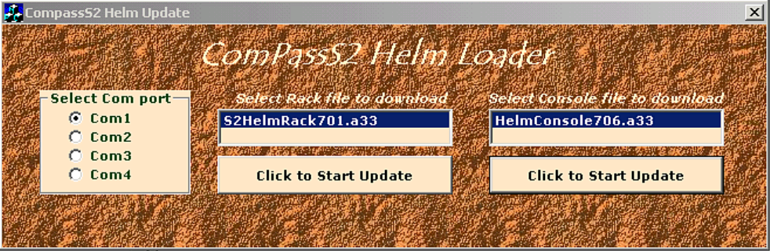

Do not have any S2 units attached while uploading!

Update the HELM Console FIRST:

- Insert the 4 pin phoenix to 4 pin XLR cable between the S2 HELM CONSOLE and the S2 HELM RACK.

- Insert the DB9 Male to DB9 Female straight through serial cable between the computer COMM port and the “UPDATE” port on the S2 HELM CONSOLE.

- Double click the HelmLoader icon on your desktop.

- Select the serial port to use. (Usually COM1)

- Select (single click) the “Helm Console 706.a33”to highlight it.

- Click on ‘Click to Start Update’

- If the ‘Communication Error Check Cabling’ box is displayed there’s a problem with either your pc port or cable.

- A progress bar will show the progress of the download. A ‘Download Complete, “Cycle Helm power” message will appear S2 HELM CONSOLE update is completed.

Updating the S2 HELM RACK.

- Unplug the4 pin phoenix to 4 pin XLR cable from the interface unit.

- Insert the DB9 Male to DB9 Male straight through serial cable cable between the computer port and the update port on the HELM RACK.

- Double click the HelmLoader icon on your desktop.

- Select the serial port to use.

- Select (single click) the “S2HelmRack801.a33” to highlight it.

- Click on ‘Click to Start Update’

- If the ‘Communication Error Check Cabling’ box is displayed there’s a problem with either your pc port or cable.

- A progress bar will show the progress of the download.

- At the end a ‘Download Complete, Cycle Helm power’ box will appear the update is done.

- Reconnect the4 pin phoenix to 4 pin XLR cable from the interface unit. Remove the DB9 Male to DB9 Male straight through serial cable.

- Recycle the power to the S2 HELM.

- Press the blank button to the right of the PIP button on the S2 HELM console to view the currently running versions of the S2 HELM RACK and S2 HELM CONSOLE when the units are running to confirm that both units were upgraded successfully. The new firmware version numbers should appear in the VFD display window.

